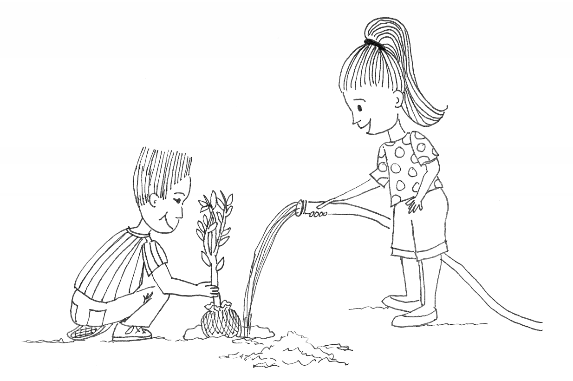

Kim and Pamela Planting a Tree