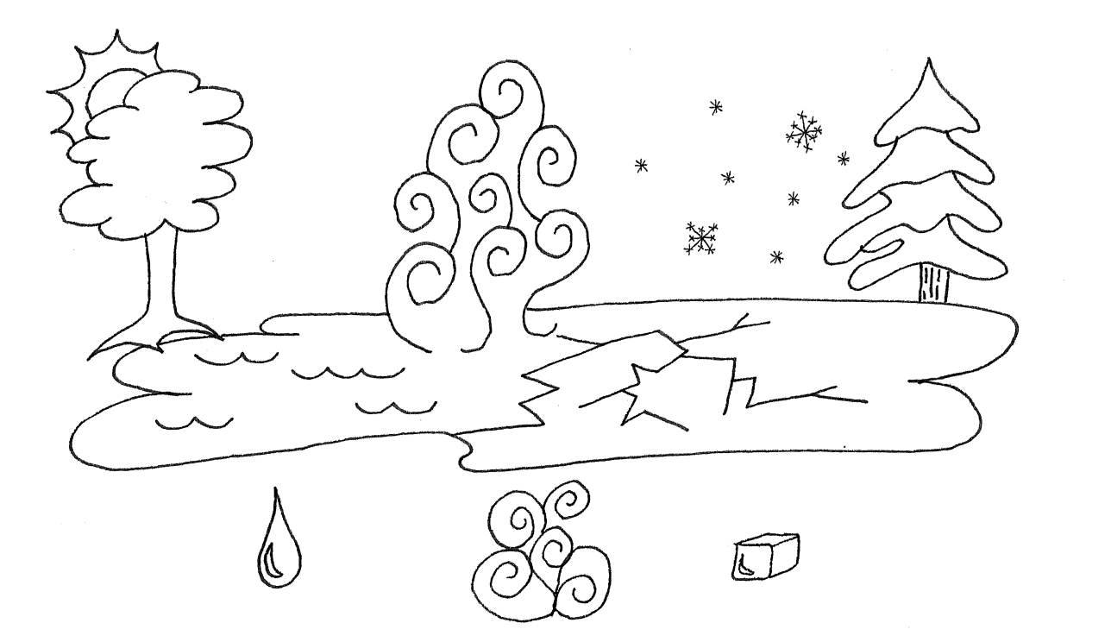

Water as Liquid, Gas and Solid